642115016 Danaikrit

642115022 Thanapong

642115026 Phacharanan

642115035 Pharanya

642115045 Sorawee

**Feature : Real-time Claim Tracker**

**Feature Prioritization Criteria :**

**Business Value:** How much revenue or profit will this feature bring? Does it align with company goals?

* **Revenue/Profit Potential:** Evaluate how much additional revenue or profit the feature can generate. Consider factors like pricing, market demand, and potential upsell opportunities.
* **Alignment with Company Goals:** Assess whether the feature aligns with the company's strategic objectives and long-term vision. Features that contribute to core business goals should be prioritized higher.

**User Demand:** How many users have requested or shown interest in this feature?

* **User Requests:** Consider the number of users who have explicitly requested this feature. Frequent requests from a significant portion of your user base indicate high demand.
* **Market Research:** Analyze user feedback, surveys, and market research to gauge general interest and demand for the feature.

**Development Effort:** How much time, resources, and cost are involved in implementing this feature?

* **Time and Resources:** Estimate the time, team resources, and associated costs required to develop and maintain the feature. Complex or resource-intensive features may need to be balanced against their potential benefits.
* **Technical Complexity:** Assess the technical challenges involved in implementing the feature. Highly complex features may take longer to develop.

**Dependencies:** Are there other features or systems that need to be in place before this can be implemented?

* **Feature Dependencies:** Identify whether the feature is dependent on other features or systems that must be in place before it can be implemented. Dependencies can affect the feature's priority.
* **External Dependencies:** Consider external factors, such as third-party integrations or regulatory requirements, that may impact feature development.

**Risk and Uncertainty:** What are the potential risks involved in implementing this feature, and how uncertain are its benefits?

* **Potential Risks:** Evaluate the potential risks associated with the feature, such as technical risks, market risks, or legal and compliance risks. Higher-risk features may require additional analysis and mitigation strategies.
* **Uncertainty:** Consider the level of uncertainty regarding the feature's benefits and outcomes. Features with unclear or speculative benefits may need further validation before prioritization.

**URS :**

URS-01 : Users should be able to login and access their claim status.

URS-02 : Users should see real-time updates of their claim's progression.

URS-03 : Users should have access to a history of their past claims.

URS-04 : The system should display detailed information, such as submission date, required documents, and processing time.

URS-05 : Users should receive real-time notifications on claim status changes.

**SRS :**

SRS-01 : The system shall provide a secure login mechanism.

SRS-02 : Post-login, the system should display a dashboard of the user's active claims with their current status.

SRS-03 : The system shall update claim statuses in real-time by pulling data from the internal claims processing system.

SRS-04 : The system shall maintain a history of each claim's status changes.

SRS-05 : The system will send push notifications or email notifications to users whenever there's a status change.

**Use Case Diagram :**

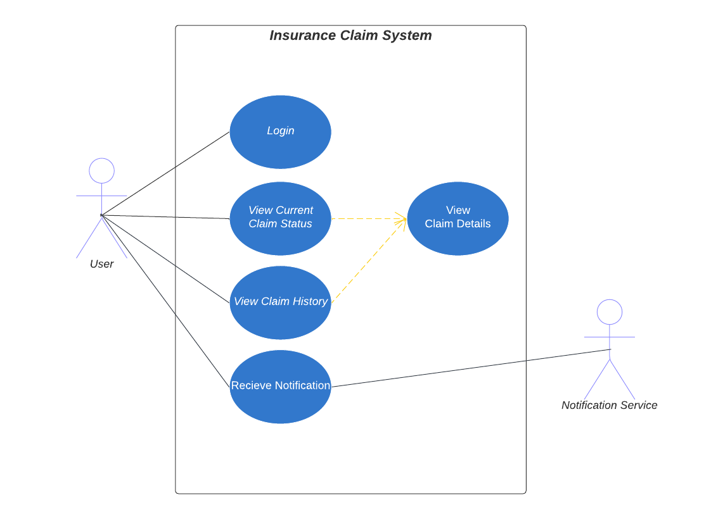

**Use Case Description :**

| Use Case ID | URS-01 | | | | |
| --- | --- | --- | --- | --- | --- |
| Use Case Name | User Login and Access Claim Status | | | | |
| Created By | Sorawee | | Last Update By | Danaikrit Jaiwong | |
| Date Created | 17 / 09 / 2023 | | Last Revision Date | 18 / 09 / 2023 | |
| Actors | User, System | | | | |
| Description |  | | | | |
| Trigger | User want to access the system | | | | |
| Preconditions | User has a registered account with the platform. | | | | |
| Use Case Input Specification | | | | | |
| Input | type |  | | |  |
| username | string |  | | |  |
| password | string |  | | |  |
| Post conditions | User is authenticated and has viewed the current status of their claim. | | | | |
| Normal Flows | User | | System | | |
|  | a. User accesses the insurance platform.  b. User provides their registered credentials (username and password).  c. User navigates to the "Claim Status" section.  d. User views the current status of their claim. | | a. System prompts for user login credentials.  b. System validates credentials and logs the user in.  c. System fetches and displays the current status of the user's claim upon navigation. | | |
| Alternative Flow | a. Invalid Credentials  b. Forgot Password | | | | |
| Exception Flow | Invalid login credentials provided. | | | | |
| Assumption | The user has access to a stable internet connection. | | | | |

| Use Case ID | URS-02 | | | | |
| --- | --- | --- | --- | --- | --- |
| Use Case Name | View Real-time Claim Progression | | | | |
| Created By | Danaikrit Jaiwong | | Last Update By | Danaikrit Jaiwong | |
| Date Created | 17 / 09 / 2023 | | Last Revision Date | 18 / 09 / 2023 | |
| Actors | User | | | | |
| Description | This use case enables users to view real-time updates and progression of their insurance claims. | | | | |
| Trigger | User wants to check the progression of their claim. | | | | |
| Preconditions | User has an active claim with the system. | | | | |
| Use Case Input Specification | | | | | |
| Input | type |  | | |  |
|  |  |  | | |  |
| Post conditions | User has up-to-date information on their claim's status. | | | | |
| Normal Flows | User | | System | | |
|  | a. User logs in to the system.  b. User navigates to the "Claim Progression" section.  c. User views real-time updates and progression of their active claim. | | a. System prompts for user login credentials.  b. The system provides access to this section.  c. The system fetches and displays live information about the user's active claim, updating it as necessary. | | |
| Alternative Flow | 1.System detects no previous claims for the user.  2.System cannot retrieve claim history. | | | | |
| Exception Flow | Claim Not Found | | | | |
| Assumption | The system provides real-time claim updates. | | | | |

| Use Case ID | URS-03 | | | | |
| --- | --- | --- | --- | --- | --- |
| Use Case Name | Access History of Past Claims | | | | |
| Created By | Danaikrit Jaiwong | | Last Update By | Danaikrit Jaiwong | |
| Date Created | 17 / 09 / 2023 | | Last Revision Date | 18 / 09 / 2023 | |
| Actors | User | | | | |
| Description | This use case allows users to access a history of their past insurance claims within the system. | | | | |
| Trigger | User wants to view their past claims. | | | | |
| Preconditions | User has a registered account with past claims recorded in the system. | | | | |
| Use Case Input Specification | | | | | |
| Input | type |  | | |  |
|  |  |  | | |  |
| Post conditions | User can view a history of their past insurance claims. | | | | |
| Normal Flows | User | | System | | |
|  | a. User logs in to the system.  b. User navigates to the "Claim History" or "Past Claims" section.  c. User views a list of their past insurance claims. | | a. The system authenticates the user and grants access.  b. The system provides access to this section.  c. The system retrieves and displays a list of the user's previous claims for their review. | | |
| Alternative Flow | 1.System detects no previous claims for the user.  2.System cannot retrieve claim history. | | | | |
| Exception Flow | The user does not have any past claims recorded | | | | |
| Assumption | The system records and maintains a history of the user's past claims. | | | | |

| Use Case ID | URS-04 | | | | |
| --- | --- | --- | --- | --- | --- |
| Use Case Name | Display Detailed Claim Information | | | | |
| Created By | Danaikrit Jaiwong | | Last Update By | Danaikrit Jaiwong | |
| Date Created | 17 / 09 / 2023 | | Last Revision Date | 18 / 09 / 2023 | |
| Actors | User | | | | |
| Description | This use case enables users to access detailed information about their insurance claims, including submission date, required documents, and processing time. | | | | |
| Trigger | User wants detailed information about a specific claim. | | | | |
| Preconditions | User has an active or past insurance claim recorded in the system. | | | | |
| Use Case Input Specification | | | | | |
| Input | type |  | | |  |
|  |  |  | | |  |
| Post conditions | User can access detailed information about their selected claim. | | | | |
| Normal Flows | User | | System | | |
|  | a. User logs in to the system.  b. User navigates to the "Detailed Claim Information" section.  c. User selects a specific claim from the list.  d. User views submission date, required documents, and processing time for the selected claim. | | a. The system authenticates the user and grants access.  b. The system provides access to this section.  c. The system allows the user to choose a particular claim from a list.  d. The system displays detailed information about the selected claim, including submission date, required documents, and processing time. | | |
| Alternative Flow | 1.System detects that certain key information for the claim is missing.  2.System cannot find a claim associated with the provided Claim ID. | | | | |
| Exception Flow | The selected claim does not exist or is not accessible | | | | |
| Assumption | The system stores and provides detailed claim information. | | | | |

| Use Case ID | URS-05 | | | | |
| --- | --- | --- | --- | --- | --- |
| Use Case Name | Receive Real-time Claim Status Notifications | | | | |
| Created By | Danaikrit Jaiwong | | Last Update By | Danaikrit Jaiwong | |
| Date Created | 17 / 09 / 2023 | | Last Revision Date | 18 / 09 / 2023 | |
| Actors | User | | | | |
| Description | This use case allows users to receive real-time notifications regarding changes in the status of their insurance claims. | | | | |
| Trigger | The status of the user's insurance claim changes. | | | | |
| Preconditions | User has an active insurance claim with notifications enabled. | | | | |
| Use Case Input Specification | | | | | |
| Input | type |  | | |  |
|  |  |  | | |  |
| Post conditions | User receives real-time notifications about claim status changes. | | | | |
| Normal Flows | User | | System | | |
|  | a. User logs in to the system.  b. User navigates to the "Notification Settings" or "Claim Notifications" section.  c. User enables real-time notifications for their insurance claims. | | a. The system authenticates the user and grants access.  b. The system provides access to this section.  c. The user sets up notifications for their insurance claims in real-time. | | |
| Alternative Flow | 1.Notification Service detects that the user has disabled real-time notifications.  2.Notification Service fails to send a notification. | | | | |
| Exception Flow | There is an issue with delivering a notification | | | | |
| Assumption | The system provides real-time notifications for claim status changes based on user preferences. | | | | |

**Activity Diagram :** 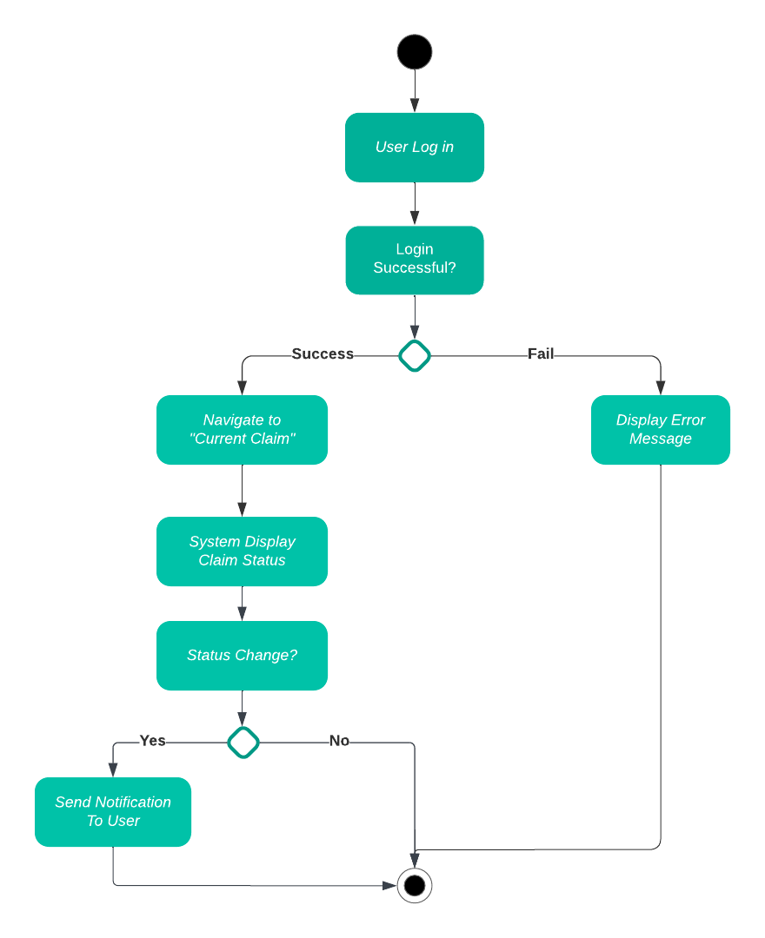

**Non-Functional Requirement With Fit Criteria :**

1. **Security**

* All user data must be encrypted during transmission and storage.
* User authentication and authorization mechanisms should be implemented and tested.
* The system should have measures in place to prevent unauthorized access to sensitive claim information.
* Regular security audits and penetration testing should be conducted to identify and mitigate vulnerabilities.

1. **Performance**

* The system should be able to handle concurrent access from a minimum of 1000 users without significant performance degradation.
* Claim status updates should be displayed in real-time, with a maximum delay of 5 seconds from the time of the update in the internal claims processing system.
* Response times for user interactions (e.g., loading the claim history or receiving notifications) should not exceed 2 seconds.

1. **Scalability**

* The system should be designed to scale horizontally to accommodate increased user load during peak usage times.
* It should support at least a 20% growth in user base annually without requiring a complete system overhaul.

1. **Reliability**

* The system should have a minimum uptime of 99.9% over a rolling 12-month period.
* Regular automated backups of user data and claim information should be maintained.
* A disaster recovery plan should be in place and tested annually.

1. **Usability**

* The user interface should be intuitive, with a user satisfaction rating of at least 4 out of 5 in user surveys.
* User onboarding and training materials should be provided, and the system should have a help section accessible to users.
* The system should comply with accessibility standards (e.g., WCAG) to ensure usability for all users, including those with disabilities.

1. **Compliance**

* The system should adhere to all relevant data protection regulations and compliance standards in the region where it is deployed.
* Regular compliance audits and assessments should be conducted to ensure ongoing adherence to regulatory requirements.

1. **Maintainability**

* The system's codebase should follow best practices and coding standards to facilitate ease of maintenance.
* Updates, patches, and bug fixes should be deployed within 48 hours of identification for critical issues and within 2 weeks for non-critical issues.

**UI (wireframe or prototype) :** https://shorturl.at/rHJM7



